**Qwertycoin** **White Paper**

QWERTYCOIN **[Ticker: QWC]** is a digital crypto-currency designed for everyday use. It supports simple CPU/GPU mining and masternode operations, Desktop / Mobile / Web wallets are provided for user’s accessibility to QWERTYCOIN across multiple platforms.

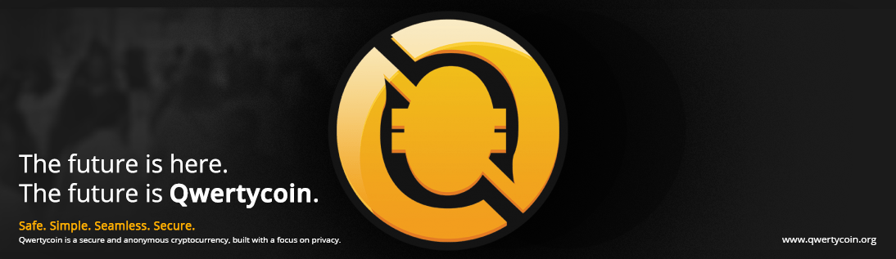

**FEATURES**

* **Anonymous, Unlinkable and Untraceable Transactions** - Based on CryptoNote V2.0 Technology over a decentralized network.
* **Egalitarian Proof of Work (EPoW)** – Through Cryptonight-base algorithm with LWMA difficulty algorithm.
* **Egalitarian Proof of Service (EPoSe)** – Transaction fee distribution among master nodes based on Uptime as a measure of service.
* **Reserve Requirement System** - Development fees and donations collected over time will be stored in QWERTYCOIN Foundation.
* **No Pre-mining** - Community owned system and transparent developments and operations.
* **Free Master Nodes** - No mandatory minimum coin commitment to run Master Nodes.
* **Free Community Faucet** – Free QWC every 24 hours from community donations.
* **Transparent Operations and Management** – All accounts run by community funds can be monitored using tracking keys.

**TECHNICAL SPECIFICATIONS**

* Total Number of Coins: 184.47 Billion
* Current Target Block Time: 120 seconds -> 20 seconds
* Time for Transaction Hashes: Instant (<4 seconds)
* Core Design: CryptoNote V2.0 – Forked from Bytecoin, Monero + Karbowanek + Digitalnote and Qwertycoin V1.0

**ULTIMATE PROJECT GOALS**

* Development of User-Friendly Wallet Software for Desktop/Mobile Computers, Web and Mobile Phones
* Q-Life app with chat + wallet + crypto exchange + store locator
* Robust Network (< 50 PPM Blockchain Split) with Blockchain/Network Monitoring Tool for all users
* Network Explorer feature that allows monitoring of blockchain
* User Population over 1 million
* E-Commerce/Woo-Commerce Integration + Local Stores as Fiat Exchange

**Index**

1. **Introduction**
2. **Vision**
3. **How to Get Coins [Mining]: Egalitarian Proof of Work (EPoW - Cryptonight Based Variant)**
4. **Transition from EPoW to EPoSe in QWC Network**
5. **How to Get Coins [Masternode]: Egalitarian Proof of Service (EPoSe - QWC Original)**
6. **Blockchain Development Roadmap**
7. **Exchange Listing and Pricing Strategies**
8. **Future Directions for the Team**

**Introduction**

Qwertycoin (Ticker: QWC) is a real community cryptocurrency, a decentralized digital asset, like Bitcoin. It is based on CryptoNote Technology V2.0. Nobody owns or controls Qwertycoin. It allows anonymous and trustless peer to peer transactions through a fair PoW mining algorithm and will implement EPoSe, a new algorithm concept exclusive to QWC.

Qwertycoin transactions are untraceable, unlinkable and your privacy is protected. Mathematics secures the QWC network and empowers individuals to control their own finance and information.

**Official Links:**

Github Source Code: <https://github.com/qwertycoin-org>

Bitcoin Talk Thread: <https://bitcointalk.org/index.php?topic=2881418.0>

Desktop Wallet & Daemon Download for Windows, Linux and MacOS: <https://qwertycoin.org/wallet/#downloads>

Web Wallet: <https://myqwertycoin.com>

Mobile Wallet for iOS and Android: Please visit iOS App Store and Google Play Store

Official pool: <https://pool.qwertycoin.org>

3rd Party Pools: <https://explorer.qwertycoin.org/#pools>

Master Node Daemon Download: <https://qwertycoin.org/wallet/#downloads> / CLI versions of wallet software is Master Node software.

Master Node Map: <https://nodes.qwertycoin.org>

Voting Platform: <https://voting.qwertycoin.org>

Light Theme Logo: <https://cdn.qwertycoin.org/images/other/qwclogo-512x512.png>

**Community Links:**

Telegram: <https://t.me/qwertycoin>

Facebook: <https://www.facebook.com/Qwertycoin-422694361519282/>

Discord: <https://discord.gg/U5amwCs>

Twitter: <https://twitter.com/Qwertycoin_QWC>

Reddit: <https://www.reddit.com/r/QWERTYCOIN/>

**Support & Contact Information:**

Telegram: <https://t.me/qwc_support>

Email: [support@qwertycoin.org](mailto:support@qwertycoin.org)

**Vision**

* **Reliable, fast and easy to use / user-friendly blockchain service**
* **Decentralized development from crowd efforts and funding**
* **Privacy protection for the members of its network**
* **Abundant supply to allow a fair distribution among a large number of members**

Qwertycoin (QWC) team envisions the future of finance relies on distributed ledger technology, the blockchain. Unlike traceable bitcoin, QWC developers applied Cryptonote Technology V2.0, which has been verified to provide anonymity of users from the earlier generations of cryptocurrencies.

Everyone is free to join all QWC network and use its services at a low cost. However, QWC requires a central authority for the development and the management of QWC network and blockchain. Community engagements and donations are necessary to keep the development moving forward.

QWC team operates under the unanimous consensus of transparent management for all its members.

[Figure 1. Total QWC in Circulation per Bloch Height]

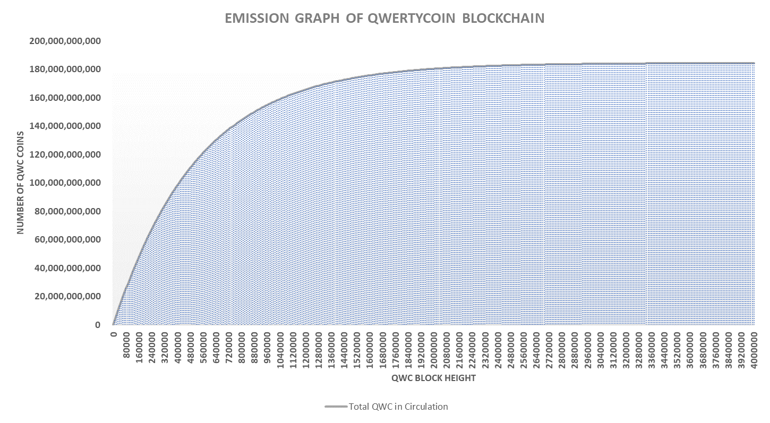

[Figure 2. Total QWC in Circulation per Date]

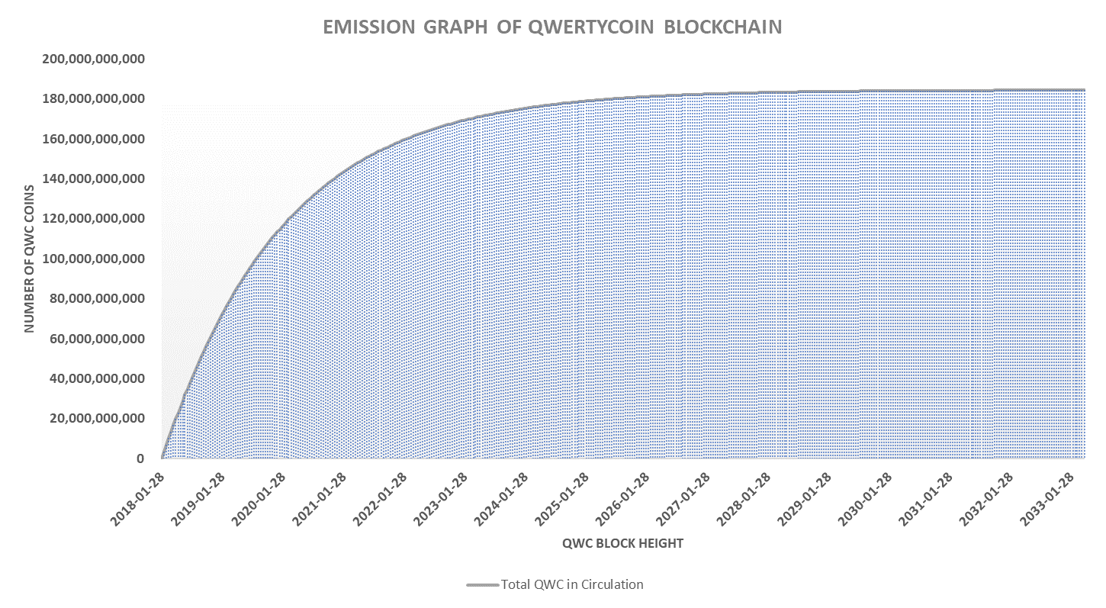

**How to Get Coins [Mining]: Egalitarian Proof of Work (EPoW – Cryptonight Based Variant)**

The word egalitarian stands for providing equal rights and equal opportunities. QWC network is an open source and is driven by community members. Anyone can join and support the network and get coins as compensation to their support through mining.

Cryptonote Technology V2.0 has a built-in block reward system called emission rate. It is a shape of log function and, because of its original design, QWC block rewards will reduce by each block found and eventually reach a point called ‘tail emission’.

QWC has an emission factor of 19. Please refer to below graphs to see how block rewards are reduced over time.

[Figure 3. Block Reward Reduction per Block Height]

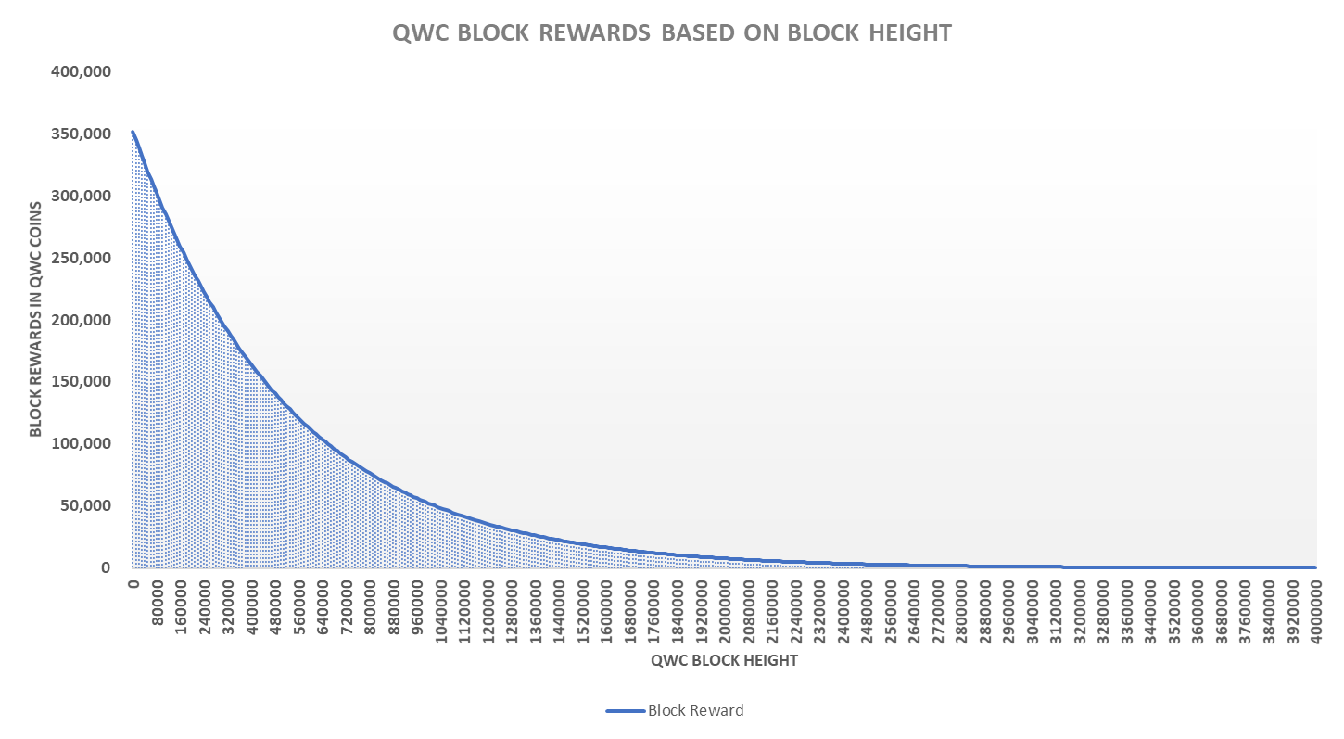

[Figure 4. Block Reward Reduction per Date]

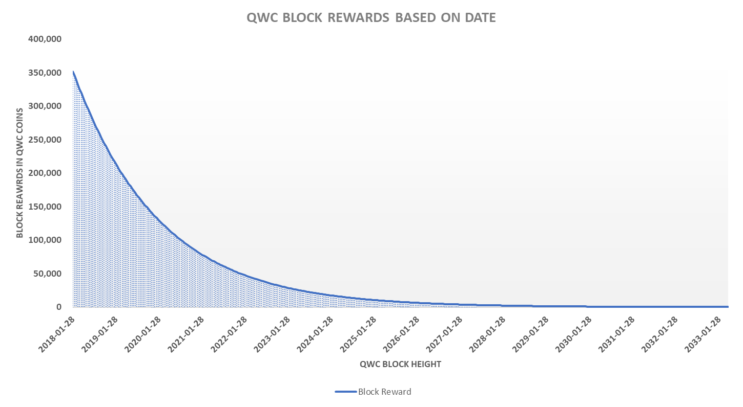

* History of Mining Algorithm Changes

|  |  |  |  |  |
| --- | --- | --- | --- | --- |
|  | Block Height | From | To | Supporting Mining Equipment and Service |
| Initial | 0 | Cryptonight | - | CPU, GPU, FGPA, ASIC, Nicehash |
| 1st Change | 115,250 | Cryptonight | Cryptonight- Heavy | CPU, GPU / The rest are penalized. |
| 2nd Change | 250,720 | Cryptonight Heavy | Cryptonight | CPU, GPU, FGPA, ASIC, Nicehash |
| 3rd Change | T.B.D. | T.B.D. | T.B.D. | T.B.D. |

Qwertycoin core team is committed to reflect the decisions of the community regarding major changes in the future through community voting system.

Please go to our explorer page (<https://explorer.qwertycoin.org/#pools>) and select a pool to mine from. Each pool provides information and a guide to setup for mining. Users can also mine with CPU using a built-in mining feature in QWC Desktop Wallet Software.

Make sure to create a wallet address before you start mining QWC. You can download QWC user manual for the assistance.

**Transition from EPoW to EPoSe in QWC Network**

As with any other blockchain technologies, QWC block height will increase over time, which also results in the blockchain data file growing continuously in a linear trend. With block time of 120 seconds and 1 MB block size, QWC blockchain size can increase close to **4 TB** at **99.95%** QWC circulation rate. Even after considering the storage capacity of consumer PC market is currently averaged at 500GB, the size of full blockchain data can be a problem for new users of QWC blockchain.

Eventually, the users of desktop wallet software are expected to connect their wallet software through remote nodes to reduce the percentage of their local hardware resource usage, while having an option to download the complete QWC blockchain data and sync in their local computers.

QWC team also realizes that

1. block rewards against energy consumption for EPoW mining process will become inefficient for the network and harmful to our environment in the later stage of QWC blockchain.
2. mobile wallet application will require remote nodes (without downloading blockchain file) for transactions.

Therefore, it is inevitable that QWC blockchain algorithm has to shift from individual miners(EPoW) to competent node operators(EPoSe) as more coins are mined towards QWC’s maximum supply limit of 184.47 billion and the adaption rate of mobile wallet application increases over time.

[Figure 5. Blockchain Size per Block Height]



[Figure 6. Blockchain Size per Date]



One of the major challenges QWC members needs to consider for this algorithm transition is a heavy market correction arising from excluding existing mining population from the network, because EPoSe [Masteronde] algorithm does not allow more profits by providing a high hash rate.

The appropriate timing for this transition is to be decided by the community members. In this paper, proposed timings for this change are provided in Table 1 for our members to make informed decisions.

[Figure 7. Block Reward Reduction up to Block Height 2,000,000]



[Table 1. Transition Timing Proposal from EPoW to EPoSe]

|  |  |  |  |  |  |  |
| --- | --- | --- | --- | --- | --- | --- |
| Transition Timing Table | Proposal #1 | Proposal #2 | Proposal #3 | Proposal #4 | Proposal #5 | Proposal #6 |
| QWC Block Height: | 200,000 | 250,000 | 300,000 | 350,000 | 400,000 | 450,000 |
| Single Block Reward: | 240,000 QWC | 218,000 QWC | 198,500 QWC | 180,400 QWC | 164,000 QWC | 149,000 QWC |
| 24 Hour Block Reward: | 172,800,000 QWC | 156,960,000 QWC | 142,920,000 QWC | 129,888,000 QWC | 118,080,000 QWC | 107,280,000 QWC |
| Expected Number of Mobil Users: | 100 Users | 150 Users | 300 Users | 350 Users | 400 Users | 450 Users |
| Expected Storage Capacity: | 200 GB | 250 GB | 300 GB | 350 GB | 400 GB | 450 GB |
| Expected Net Hash Rate: | 2.0 MH | 2.5 MH | 3.0 MH | 3.5 MH | 4.0 MH | 4.5 MH |
| Expected Daily Return of  1K Hash Rate: | 86,400 QWC | 62,784 QWC | 47,640 QWC | 37,110 QWC | 29,520 QWC | 23,840 QWC |
| GPU Mining Profitability*: | QWC > 0.00002 USD | QWC > 0.00003 USD | QWC > 0.00004 USD | QWC > 0.00005 USD | QWC > 0.00006 USD | QWC > 0.00008 USD |
| CPU Mining / Node Profitability**: | QWC > 0.000004 USD | QWC > 0.000006 USD | QWC > 0.000008 USD | QWC > 0.000010 USD | QWC > 0.000012 USD | QWC > 0.000016 USD |
| Expected Date of Height: | 2018.11.3 | 2019.1.2 | 2019.3.22 | 2019.5.31 | 2019.8.8 | 2019.10.17 |

[Table 2. Transition Timing Proposal from EPoW to EPoSe]

|  |  |  |  |  |  |  |
| --- | --- | --- | --- | --- | --- | --- |
| Transition Timing Table | Proposal #7 | Proposal #8 | Proposal #9 | Proposal #10 | Proposal #11 | Proposal #12 |
| QWC Block Height: | 500,000 | 700,000 | 900,000 | 1,000,000 | 1,500,000 | 2,000,000 |
| Single Block Reward: | 135,000 QWC | 92,500 QWC | 63,200 QWC | 52,000 QWC | 20,000 QWC | 7,750 QWC |
| 24 Hour Block Reward: | 97,200,000 QWC | 66,600,000 QWC | 45,504,000 QWC | 37,440,000 QWC | 14,400,000 QWC | 5,580,000 QWC |
| Expected Number of Mobil Users: | 500 Users | 700 Users | 900 Users | 1,000 Users | 1,500 Users | 2,000 Users |
| Expected Storage Capacity: | 500 GB | 700 GB | 900 GB | 1.0 TB | 1.5 TB | 2.0 TB |
| Expected Net Hash Rate: | 5.0 MH | 7.0 MH | 9.0 MH | 10.0 MH | 15.0 MH | 20.0 MH |
| Expected Daily Return of  1K Hash Rate: | 19,440 QWC | 9,514 QWC | 5,056 QWC | 3,774 QWC | 960 QWC | 279 QWC |
| GPU Mining Profitability*: | QWC > 0.0001 USD | QWC > 0.0002 USD | QWC > 0.0004 USD | QWC > 0.0006 USD | QWC > 0.0022 USD | QWC > 0.008 USD |
| CPU Mining / Node Profitability**: | QWC > 0.000025 USD | QWC > 0.00004 USD | QWC > 0.00008 USD | QWC > 0.00012 USD | QWC > 0.0004 USD | QWC > 0.0016 USD |
| Expected Date of Height: | 2019.12.25 | 2020.9.28 | 2021.7.3 | 2021.11.18 | 2023.10.14 | 2025.9.7 |

* The assumption for GPU mining profitability is calculated based on AMD GPU with Cryptonight hash rate of 1,000.  
** The assumption for the CPU mining / node profitability is calculated based on AMD CPU with Cryptonight hash rate of 1,000.  
*** Mining profitability can be changed depending on net hash rate and both variables have a inversely proportional relationship.

**How to Get Coins [Masternode]: Egalitarian Proof of Service (EPoSe – QWC Original)**

Again, the word egalitarian stands for providing equal rights and equal opportunities. It is free to run a QWC masternode since node reward program does not offer a staking option for providing a node. In order for nodes to receive rewards, a node must be configured and used as a remote daemon in wallet software. Based on the number of transactions processed in remote daemon connections, Maximum 10 QWC is rewarded per transaction. [June 29th, 2018]

QWC nodes perform following tasks in the network.

1. Holding transactions in the memory pool so that a miner can find a block with a group of these transactions
2. Verifying one-time ring signature of entire blockchain
3. Validating correct blockchain during a chain split from PoW
4. Propagating validated blockchain to all daemons running in our network

As QWC develops and brings more traffic to our network, the performance of these nodes will be very critical to our success for following reasons.

1. When blockchain size increases, it will take more time to synchronize with the network since desktop wallets are mostly not online.
2. Mobile wallets will always use a remote daemon feature and network sync will be instant.

QWC team believes that the existing PoS reward system is not fair since the cost of running a node can be more than its rewards for the amount of work they provide to the network, and node information is currently not available when wallet users want to choose a remote daemon. In order to change this, QWC will implement EPoSe system.

EPoSe is based on the concept of dedication in terms of service duration of nodes for their conformance, performance and reliability within QWC network. It features is a block reward program for node operators based on dedicated service time (Uptime).

There are 4 components to make EPoSe work.

1. Nodes, run by network participants
2. Sentinel, which checks the status of nodes periodically filters nodes based on conformance and performance criteria
3. Node Map, which shows geographical information of operating nodes
4. Network Explorer, which displays the network status of node and detailed information.

Sentinel provides API of online-node information after checking node’s conformation to network requirements and the performance of its hardware and internet speed as well as 24-hour and Uptime measurements to Network Explorer(NE). NE displays information from Sentinel to allow users to select desired nodes while having the ability to check the overall status of each node. The API provided by Sentinel will be available for the selection of remote nodes.

There will be several conformance and performance criteria evaluation for nodes of which the data will be identified / measured / stored / analyzed to determine nodes eligible for the rewards of accumulated transaction fees over a set period. Through QWC’s solution towards scalability,

EPoSe reward system has following features:

1. Rewards: accumulated transaction fees, which has been traditionally awarded to miners, are switched to node operators. Depending on the current operation costs of nodes, this reward scheme will be adjusted when deemed necessary.
2. Reward Period: 24 hours UTC time
3. EPoSe algorithm functions just like mining but provides infinite rewards throughout the lifetime of QWC blockchain without causing any inflation.

[Table 1. Transaction Fee & EPoSe Rewards Estimation]

|  |  |  |  |  |  |  |  |  |
| --- | --- | --- | --- | --- | --- | --- | --- | --- |
| Median  Tx Size | Max. Blk. Size | Tx per block | Daily Tx Throughput | Transaction Fee | Multiplier | Transaction Fee (Approx.) per Blk. | Blk.  per Day | Est. Tx Rewards Available for Uptime Nodes |
| <= 5 kb | 1 mb | 200 Tx | 144,000 Tx | 20 QWC/kb | 1.0 X | 20,000 QWC | 720 | 14,400,000 QWC + Mining Block Rewards |
| <= 25 kb | 1 mb | 40 Tx | 28,800 Tx | 500 QWC/Tx | 5.0 X | 20,000 QWC | 720 | 14,400,000 QWC + Mining Block Rewards |
| <= 100 kb | 1 mb | 10 Tx | 7,200 Tx | 2,000 QWC/Tx | 20.0 X | 20,000 QWC | 720 | 14,400,000 QWC + Mining Block Rewards |
| <= 200 kb | 1 mb | 5 Tx | 3,600 Tx | 4,000 QWC/Tx | 40.0 X | 20,000 QWC | 720 | 14,400,000 QWC + Mining Block Rewards |
| <= 300 kb | 1 mb | 3 Tx | 2,160 Tx | 6,670 QWC/Tx | 66.7 X | 20,000 QWC | 720 | 14,400,000 QWC + Mining Block Rewards |
| <= 400 kb | 1 mb | 2 Tx | 1,440 Tx | 8,000 QWC/Tx | 80.0 X | 20,000 QWC | 720 | 14,400,000 QWC + Mining Block Rewards |
| > 400 kb | 1 mb | 1 Tx | 1,440 Tx | 10,000 QWC/TX | 100.0 X | 20,000 QWC | 720 | 14,400,000 QWC + Mining Block Rewards |

**Blockchain Development Roadmap**

1. Stage 1: Currency Application Development (2017 – By the end of 2019)
   * Daemon Development and Optimization
   * CLI Wallet / Desktop Wallet Development and Optimization
   * Web Wallet / Mobile Wallet Development and Optimization
   * Commerce Plug-In Integration Development

* The core team wants to review the entire codebase of CryptoNote V2.0 forked from previous blockchains and acquire better understandings of the codes while making improvements & adjustments during this period. This is the ground work required to start Stage 2 of development.
* Known bugs for Qwertycoin software and Cryptonote codebase are being patched and fixed.
* Travis CI and Appveyor CI checks added.
* Codecov is implemented to check code coverage of Unit Test.
* C++ linting was performed for internal codes excluding 3rd party files to make all codes more readable.
* Redundant codes were removed
* C++ Cross compilation package manger [Hunter/Polly] is implemented for easy compilation work even for inexperienced users.
* Automatic Github release deploy feature is added.
* Zero GUI wallet is added.
* Web wallet and android mobile wallet is released.
* Multi-language support for all GUI, web and mobile wallets
* DB implementation pending
* Multi-signature (smart contract) feature pending

1. Stage 2: Currency Application Development (2020 – By the end of 2021)
   * EPoSe Implementation – Addition of PoS, turning QWC for both PoW and PoS
   * Consensus Update
   * Fine tuning of PoW
2. Stage 3: Currency Ecosystem Development (2018 – Continuous)
   * Invitation/Integration of Existing Commerce Applications (V)
   * Commerce Integration Optimization
   * Local Fiat Exchange Commerce
   * Patches and Updates for All Software
3. Stage 4: Application Development and Deployment (2019 – Continuous)
   * Search Engine + Desktop/Web/Mobile Wallet
   * Web Services + Web/Mobile Wallet (V)
   * Native Mobile Apps + Mobile Wallet (U)
   * Activation of Local Fiat Currency Exchange (Stores)
   * Business Applications

Please check the current status of the roadmap from the official webpage. (V) and (U) stand for done and under development status respectively.

**Exchange Listing and Pricing Strategies**

It is important to inform our members that your registrations on exchange platforms with personal information such as ID and bank/credit card accounts will/can expose your identity and your actions and outcomes from trading activities can be subjected to applicable laws and regulations.

In the early stage, QWC experienced issues with exchanges (Octaex(China), Crepcoin Exchange(Decentralized), Altex Exchange(Decentralized)) arising from various factors such as delays or lack of support, site shut-downs and service terminations, which caused damages to QWC members.

From past experience and failure to select proper exchanges for trading, the listing strategies for QWC are the followings:

* To have as many trading pairs as possible across multiple platforms
* To be listed on exchanges a verified business entity with a registration with transparency, reputation, volume and history
* To be listed on market tracker websites for broaden market exposure and bring awareness

**Listed Exchanges**

1. Crex24/Estonia – Funded by QWC Team [BTC]
2. BitexLIVE/Turkey – Funded by QWC Team [BTC (when QWC > 1 Satoshi) / DOGE]
3. Fedlio/Singapore or Seychelles – Funded by QWC Team [ETH / BCHABC / DASH] – Warning for withdrawal issues!
4. Bisq/Decentralized – Promoted by QWC Team [BTC] – Requires Activation Cost.
5. Bituan/China – Promoted by QWC Chinese Community [USDT]
6. Citex/Korea – Promoted by QWC Chinese Community [BTC / ETH]
7. QBTC/China – Promoted by QWC Chinese Community [CNYT]
8. Tyche/Unknown – Promoted by QWC Team [ETH / USDT / DOGE / TEX]
9. Altilly/HK – Funded by QWC Team [BTC / ETH / DOGE / XQR]

QWC community members should be aware that the listing contract can be nullified if there is not enough trading volume.

**Next Target Exchanges**

1. STEX – To be funded by QWC Community [LTC]

**Closed Exchanges**

1. Octaex/China
2. Crepcoin/Unknown
3. Altex/Unknown

**Due to excessive listing price of major exchanges, community donations are required to help raise the fund for listing QWC on following exchanges.**

* Binance, HitBTC, Bittrex, Poloniex and other exchanges will be possible candidates or our own exchange.

**A brief explanation regarding initial listing price:**

Qwertycoin team firmly believes in the free market theory. That is why the initial listing price was at 0.01 satoshi. Our community strongly insisted on 1 satoshi listing during the poll and debate during the first exchange listing.

After listing, all other coins with similar structure had to join the initial pricing strategy of QWC because they realized 1 satoshi for 184.47 billion coins with a high emission rate is just not realistic without any form or premine or ICO/IEO.

**Future Directions for the Team and the Community Members**

**A. Multi Language Support (Wallet Software and Web)**

Qwertycoin wallet platforms(Desktop/Web/Mobile) and QWC official websites will support multiple languages. English is the default language for the software services. Additional language updates shall be requested through official communication channels.

**B. Transforming QWC into Blockchain 3.0**

QWC developers and communities shall find work towards to get below all five properties.

* High Scalability
* Interoperability
* Sustainability
* Privacy
* Governance

B-1. High Scalability

As written in the main part of this whitepaper, Blockchain size grows in linear trend under a fixed set of parameters. These configurations such as block time and block size embedded in codes will have be changed from QWC blockchain in the future depending on the outcome of QWC’s high scalability solution.

QWC proposes to solve this scalability issue by generating a new (genesis) reference block after a fixed interval. Our approach is different from a hard fork, which most cryptocurrency developers opt to choose for solving this issue.

The validation of ring signature back to genesis block will add significant loads to QWC network in the later stage of any blockchain as the number of transactions increases. To minimize this bottle neck, a mega block will be issued. Since the ring signature verifications on this mega block will be confirmed by checking all previous signatures from the previous blocks, this block can act as a new reference point for future ring signature verifications thereafter.

A complete blockchain data file up to this mega block will be backed up and stored in the conventional blockchain data base as a backup source. Users can download this complete blockchain file as well if their systems have enough processing power and storage to run wallets or nodes. If not, they can always connect to remote nodes to use QWC blockchain.

It is a type of compression that will keep our working blockchain to a manageable size in the long run. Assuming that average internet speed of 100Mbps, which can provide 12.5MB/s download speed in optimal condition, this (genesis) reference block shall be created before every 100GB of blockchain size, equivalent to 100,000 blocks (approx. 139 day interval) to allow seamless network-wide synchronization within an hour.

In order to create this genesis reference block, all wallets initiate self-transactions to assure the number of coins per address is correctly reflected in this mega block to avoid ring signature verifications back to the genesis hash of individual address for future transactions.

The prerequisites required for this plan

1. 2FA enabled wallets (preferably mobile or web wallet)
2. A permission feature in wallet to **only allow self-transactions** required for generating reference blocks.
3. Optimizing difficulty algorithm (or network propagation time setting) depending on the total size of transaction hashes to be included in the reference block to avoid any fork from possible malicious attack.
4. Synchronization (Automatic download of the reference block) feature after reference block creation for daemon.

A higher transaction fee will be charged to wallets that failed to be included(or make a self-transaction) in the reference block for additional loads on QWC network as a penalty, but it also motivates users to adapt to mobile/web wallet environment, that boosts the effectiveness of QWC’s scalability solution.

B-2. Interoperability and Privacy (Through Reserve Requirement System [The Purpose of Qwertycoin Foundation] and Billionaire Club)

The fundamental of blockchain interoperability largely depends on the basic algorithm on which cryptocurrencies are built. It will come down to choices of cryptocurrency systems or platforms that are popular and how many businesses/entities/organizations/communities are willing to build blockchains above such platform. QWC is a cryptocurrency and it means that it should be able to convert to other cryptocurrencies at users’ discretions and used as a mean of payment.

Privacy is compromised when they make a C2C or C2F transactions through an exchange platform with AML and KYC processes in place.

To solve these two issues, QWC team proposes the following solution with three prerequisites.

1. QWC Foundation - Reserve Requirement System up to 7% of maximum QWC supply (Max. 18.447 Billion QWC)
2. QWC Billionaire Club - Total holding stake of 20% of maximum QWC supply (Max. 36.894 Billion QWC)
3. QWC exchange accounts on all exchange platforms that list/trade QWC.

First, a trading solution will be developed or implemented, not in a form of a conventional exchange, but more like a bot system for all members.

C2C Transaction (Coin to Coin Exchange)  
  
Seller/Buyer -> Wallet (Transaction Fee) -> Individual Exchange (CEX/ DEX) & API-> C2C Exchange (Exchange Taker/Maker Fee)  
  
to  
  
Seller(Lender)/Buyer(Loaner) -> Qwerty Wallet -> C2C Exchange based on Best Market Price from Multi-Exchange API (CEX / DEX)  
  
1. Buyer(Loaner) checks exchange rate from wallet software.

2. The bot will allocate the best trading deal on the market among exchanges.

3. Buyer(Loaner) initiates C2C exchange upon confirming exchange rate + service fee + receiving address of exchanged coin, which sends QWC to a designated wallet address + transaction fee in QWC (% of total transaction)

4. The QWC coins funded by Seller(Lender - Reserve Requirement System and/or QWC Billionaire Club) on exchange platform will initiate C2C exchange from the market and send the exchanged coin to Buyer(Loaner)’s designated address excluding a service fee form exchanged coin unit. (% of total transaction)

5. Exchange status will be confirmed in QWC wallet software.

Pro:  
1. Personal identity is masked through this system.  
2. Buyers can receive the best market deal by taking the lowest sell order rate from Multi-Exchange API (CEX / DEX) at their fingertips.  
3. Lenders can receive the best market deal by making the highest buy order rate from Multi-Exchange API (CEX / DEX) at their fingertips + service fees.  
4. By normalizing sell price in the market, buy price is also normalized and stabilized. This will be the main difference from other cryptocurrencies in terms of trading ecosystem.  
  
Con: Investor holds risks against the overall stability of the QWC blockchain.

C2F / F2C Transaction (Coin to Fiat / Fiat to Coin Exchange)  
  
For this type of trade It is important to inform our members that your registrations on exchange platforms with personal information such as ID and bank/credit card accounts will/can expose your identity and your actions and outcomes from trading activities can be subjected to applicable laws and regulations. We are dealing with centralized currencies and their systems in the end. This service is not an option for QWC network.

For cryptocurrency to fiat exchange, it would be the best to have local stores and businesses to engage and host an individual/independent exchange to allow more decentralized network of QWC blockchain. There will be no requirement of personal information for this type of transactions.

B-3. Sustainability

Through EPoSe in place, there will be an infinite circulation of incentives among network service providers and it will energy-wise more efficient for our environments. QWC blockchain and its infrastructure is supported by the core team and the source code is provided as an open source on github for 3rd party integration. The more 3rd parties services are provided, the less involvement of core team will take place in the service.

B-4. Governance

The most important part of the governance is the incentive system for participants. Please refer to EPoW and EPoSe sections of this white paper.

Unless Process Automation or AI takes over the entire development and implementation of new features or updates, QWC blockchain will have a centralized authority run by human that develops features, manages implementations/updates and provides support for the service.

QWC team (a centralized authority that consists of a group of people who volunteer to provide services) reflects the decisions of QWC community through a community voting system. All QWC members can participate in making community-wide decisions.

**Revision History**

|  |  |  |  |
| --- | --- | --- | --- |
| Version | Author(s) | Channel | Announce Date |
| 0.1 | Xecute, QWC Team | Official Telegram | May 28th, 2018 |
| 0.7 | Xecute, QWC Team | Official Telegram | August 30th, 2018 |
| 0.9 | Xecute, QWC Team | Official Telegram, Github, Twitter, Bitcointalk | September 4th, 2018 |
| 1.0 | Xecute, QWC Team | Official Telegram, Github, Twitter, Bitcointalk | November 11th, 2018 |
| 1.1 | Xecute, QWC Team | Official Telegram, Github, Twitter, Bitcointalk | June 23th, 2019 |
| 1.2 | Xecute, QWC Team | Official Telegram, Github, Twitter, Bitcointalk | August 7th, 2019 |

**Credits**

This section provides information about QWC Core Team members and contributors. This section is to be revised periodically and previous core team members and significant contributors shall remain as well.

|  |  |  |  |  |
| --- | --- | --- | --- | --- |
| **Core Team** | | | | |
| **Name** | **Full/Part Time** | **Background** | **Role in QWC Team** | **Misc.** |
| Alex (nnian) |  |  | Lead Developer |  |
| Jeka |  |  | MacOS Lead |  |
| Pascal |  |  | IT Lead |  |
| Jordan Lovelle (Anonymous) |  |  | Team Lead & Designer |  |
| Jason (Xecute) |  |  | Team Lead & Finance Officer |  |
| Satish (Mavericminer) |  |  | Community & Marketing Manager |  |
| Brent (FranklinsAce) |  |  | Community & Marketing Manager |  |
| Jeff Lee |  |  | IT & Infrastructure |  |
| Marc (ExploShot) |  |  | Developer & Mobile Lead |  |
| Lee (Spek Oregonian) |  |  | Speaker & Marketing Manager |  |
| Michael (ghost1x) |  |  | Designer |  |
| Dennis (axecrypt) |  |  | Exchange Manager |  |

|  |  |
| --- | --- |
| **External Contributors** | |
| **Name** | **Contribution Details** |
| Spectr | Please check pull requests of qwertycoin / qwertycoin-gui / qwertycoin-zero repositories on github. |
| Blockinator | Please check wiki section of qwertycoin repository. |
| Biz | Please check on github. |

Please contribute to our cause and goals with your knowledge and service and we will gladly list your credit on this page. Everyone can participate in QWC and be a part of building a blockchain service.